

REPORT

ON

Smart Wire Monitoring and Protection System using ESP32

Bachelor of Technology

(Electronics and Communication)

Submitted to : Dr.Neha Kapila
Submitted by : K PRASANNA, 12324215
SURYA KRISHNA A P, 12308339
ALLU DILLESWERA RAO, 12318324

1. Introduction
Electrical wiring systems are one of the most essential parts of modern infrastructure. Whether it is a home, an industry, or a charging station, the entire system depends on the proper functioning of wires. However, wires are also one of the most vulnerable components, as they are exposed to physical damage, environmental conditions, wear and tear, and even theft in some cases.
In many situations, wire faults are not visible from outside. A small cut or internal damage can interrupt current flow, causing the connected device to stop working. In more serious cases, such faults can lead to overheating, sparks, or fire hazards. What makes this problem more dangerous is that most systems do not provide any early warning or automatic response mechanism.
> This is where the idea of this project comes in.
This project focuses on developing a Smart Wire Monitoring and Protection System using an ESP32 microcontroller. The system is capable of detecting whether a wire is intact or damaged and also monitors the current flowing through it. If any abnormal condition is detected, the system automatically disconnects the load and activates a buzzer to alert the user.
✔ So basically, the system does three things:
- Detects wire faults
- Protects the circuit
- Alerts the user instantly
This makes the system not just a monitoring device, but a complete safety solution.

2. Aim
The aim of this project is to design a smart and efficient system that can monitor the condition of electrical wiring, detect faults in real-time, and take immediate action to prevent damage. The system also aims to improve user awareness by providing an audible alert whenever a fault occurs.
> In simple words:
✔ Detect
✔ Protect
✔ Alert

3. Objectives
The main objectives of this project are to ensure that the system can detect even small wire faults and respond quickly without any manual intervention. It is also important that the system continuously monitors current flow, as this provides additional information about the condition of the circuit.
Another key objective is to ensure that the system is simple and cost-effective, so that it can be implemented easily in real-world applications.
> Key objectives include:
- Detect wire breakage or tampering
- Monitor current flow continuously
- Automatically disconnect the load
- Activate buzzer for alert
- Improve safety and reduce risk
- Keep the system simple and affordable

4. Problem Statement
Wire-related faults are very common but often ignored until they cause serious problems. In many systems, there is no mechanism to detect a fault immediately. For example, if a wire is cut in a remote location or during the night, the issue may remain unnoticed for a long time.
This delay in detection can lead to multiple issues:
> Major problems include:
- Sudden system failure
- Power loss and inefficiency
- Risk of fire accidents
- Damage to connected devices
- Increased maintenance cost
Another important issue is that even if the system detects a problem, it does not always inform the user immediately.
✔ So the real problem is not just detection —
> it is detection + response + alert

5. Proposed Solution
To solve this problem, a smart system is designed using ESP32 that continuously checks the condition of the wire using loop-based detection and current sensing.
The system works in a simple but effective way. A loop is formed using wires connected to the GPIO pins of the ESP32. As long as the loop is complete, the system considers the wire to be in a normal condition. If the wire is cut or tampered with, the loop breaks, and the ESP32 detects this change.
At the same time, a current sensor monitors the flow of current through the circuit. This helps in identifying conditions where the wire may not be physically broken but is not conducting properly.

6. Components Used
This project uses a combination of hardware components that work together to achieve the desired functionality.
The ESP32 microcontroller acts as the brain of the system. It reads inputs from sensors and controls outputs like the relay and buzzer. It is chosen because it is powerful, easy to program, and supports multiple input/output pins.
The INA219 current sensor is used to measure the current flowing in the circuit. It helps in identifying abnormal conditions that may not be visible through wire detection alone.
The relay module acts as a switch that connects or disconnects the load. It ensures that the system can automatically turn OFF the power supply when a fault occurs.
The buzzer is used as an alert device. It produces sound when activated, ensuring that the user is immediately aware of any issue.
> Other supporting components:
- Battery (power source)
- TP4056 charging module
- Breadboard and connecting wires

WORKING PROTOTYPE
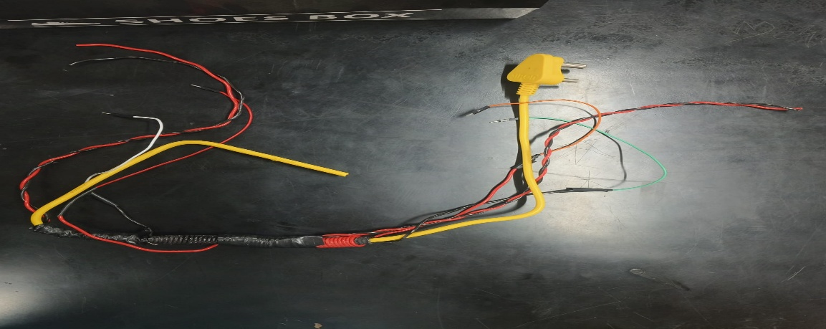

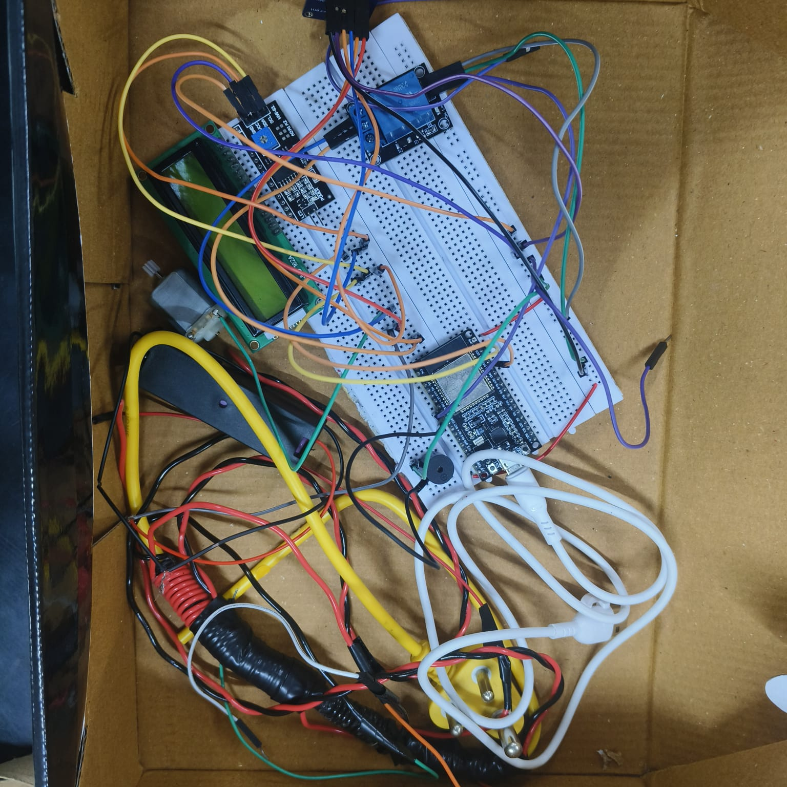

7. Working Principle
The working of the system is based on continuous monitoring and instant response.
Under normal conditions, the wire loop is complete, and the ESP32 receives a stable signal. The current sensor also detects normal current flow, indicating that everything is working properly.
> Normal condition:
- Wire intact
- Current normal
- Load ON
- Buzzer OFF

At the same time, if the current flow drops or becomes abnormal, the sensor detects it.
> Fault condition:
- Wire broken OR current abnormal
- ESP32 detects issue
- Relay turns OFF
- Load stops
- Buzzer turns ON

8. Methodology
The project was developed step by step to ensure proper understanding and implementation.
First, all the required components were selected based on availability and compatibility. After that, the circuit was designed and assembled using a breadboard.
The next step involved programming the ESP32 using Arduino IDE. The code was written to read inputs from the wire loops and current sensor and to control the relay and buzzer accordingly.
> Steps followed:
- Component selection
- Circuit design
- Coding and uploading
- Testing under different conditions
- Final adjustments
Testing was an important part of the methodology, as it helped in identifying and correcting errors.

9. Testing and Results
The system was tested under multiple conditions to ensure proper functionality.
During normal operation, the system worked as expected, with the load remaining ON and no alert being generated.
When the wire was intentionally cut, the system detected the fault immediately. The relay turned OFF the load, and the buzzer produced a clear sound alert.
Observations:
- Instant fault detection
- Accurate response
- Reliable relay operation
- Effective alert system
The results show that the system is capable of performing all required functions efficiently.

CLOUD INTEGRATION OF THE SYSTEM IN THINGSPEAK
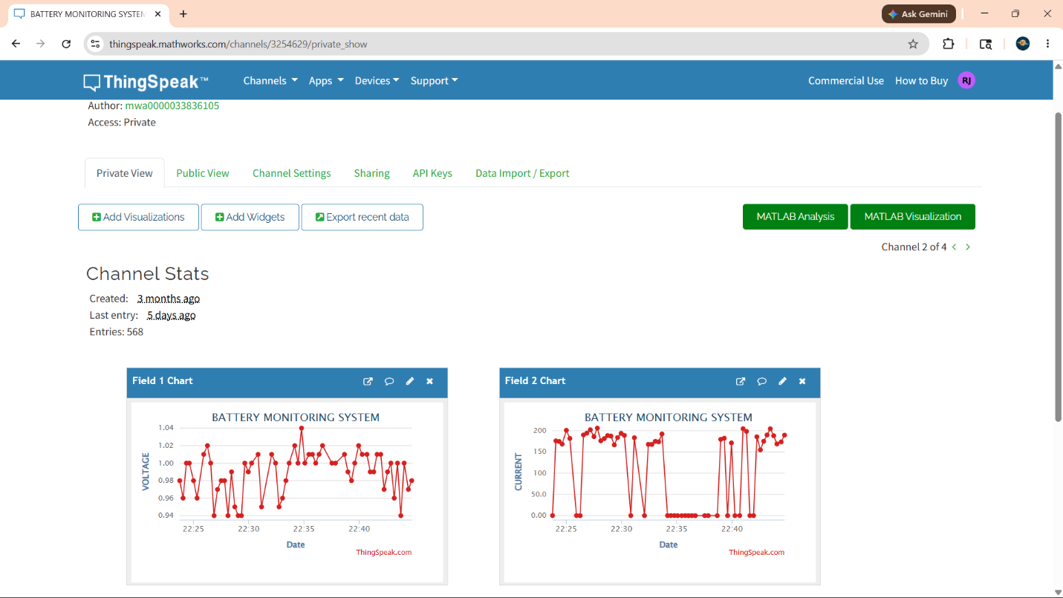
SERIAL MONITOR OUTPUT SHOWCASING CLASSIFICATION OF DAMAGE
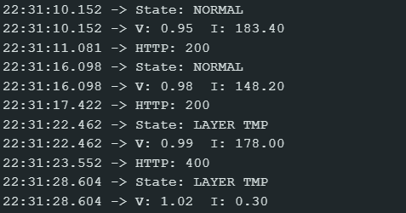

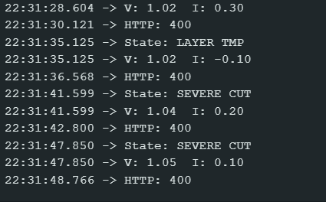

10. Applications
This system can be used in various fields where wire safety and monitoring are important.
Possible applications:
- Smart homes
- Industrial systems
- Charging stations
- Security systems
- Electrical maintenance
- Easy manipulation of timetable
- Efficient processing
These data structures make the implementation simple and effective.
11. Advantages
The proposed Smart Wire Monitoring and Protection System offers a range of advantages that make it highly practical for real-world use. One of the most important benefits of this system is its ability to provide real-time monitoring, which ensures that any fault in the wire is detected immediately without delay. This helps in preventing small issues from turning into major problems.
Another significant advantage is the automatic protection mechanism. Unlike traditional systems where manual intervention is required, this system reacts instantly by disconnecting the load through the relay. This reduces the risk of overheating, fire hazards, and damage to electrical appliances.
The inclusion of a buzzer adds an additional layer of safety by providing an immediate audible alert. This ensures that even if the user is not directly monitoring the system, they can still be informed about the fault.
Moreover, the system is designed using simple and easily available components, making it cost-effective and easy to build. This makes it suitable not only for industrial applications but also for students and small-scale implementations.
Key Advantages:
- Real-time fault detection without delay
- Automatic disconnection of faulty circuits
- Instant alert through buzzer system
- Reduces risk of electrical hazards and fire
- Low-cost and easily available components
- Simple design and easy implementation
- Reliable performance under normal conditions
- Can be extended with IoT or wireless systems
- Requires minimal human intervention
- Improves overall safety and efficiency of electrical systems

12. Limitations
Although the system performs effectively in detecting and responding to wire faults, it does have certain limitations that need to be considered. One of the main limitations is that the system primarily detects physical wire breaks or interruptions. It may not always be able to identify complex internal faults, such as minor insulation damage or partial internal breaks that do not completely interrupt the circuit.
Another limitation is related to the range of monitoring. The system is most effective when used in small-scale or controlled environments. For larger systems or long-distance wiring networks, additional components or modifications may be required to maintain accuracy and reliability.
The system also depends on proper setup and calibration. If the connections are not made correctly or if the sensor values are not properly configured, the system may give incorrect readings or false alerts. This means that careful installation is necessary.
Additionally, since the system uses basic components, it does not include advanced features like remote monitoring or data logging. This limits its functionality in modern smart systems unless further upgrades are added.
> Key Limitations:
- Cannot detect complex internal wire faults
- Limited effectiveness for large-scale systems
- Requires proper setup and calibration
- Possibility of false alerts if connections are loose
- No built-in remote monitoring or IoT feature
- Limited data analysis capability
- Depends on continuous power supply
- Not suitable for highly advanced industrial environments without upgrades
Even though these limitations exist, they can be addressed in future improvements. With the addition of advanced sensors, IoT integration, and better calibration techniques, the system can be made more powerful and reliable.

13. Future Scope
The Smart Wire Monitoring and Protection System developed in this project provides a strong foundation for building more advanced and intelligent safety systems. While the current design focuses on basic fault detection and protection, there is a wide scope for further improvement and expansion.
One of the most important future enhancements is the integration of IoT (Internet of Things). By connecting the ESP32 to the internet, the system can send real-time notifications to a mobile phone or web dashboard. This would allow users to monitor the system remotely from anywhere, making it much more useful in practical applications such as industries and smart homes.The system can also be upgraded by including advanced sensors that can detect temperature, humidity, or even sparks. This would help in identifying early signs of faults before they become serious issues.Additionally, implementing AI-based prediction systems can further enhance the system by predicting possible failures based on data trends, rather than just reacting after a fault occurs.
Key Future Improvements:
- Integration with IoT for remote monitoring
- Mobile application for alerts and control
- Cloud-based data storage and analysis
- Addition of temperature and environmental sensors
- Expansion to large-scale monitoring systems
- Wireless communication between multiple devices
- AI-based fault prediction and analysis
- GPS tracking for locating faults in large areas
- Smart automation with minimal human intervention
- Improved accuracy and sensitivity of detection
Overall, the future scope of this project is very broad. With proper upgrades, this system can evolve into a fully smart electrical safety system suitable for modern infrastructure.

14. Conclusion
In conclusion, the Smart Wire Monitoring and Protection System successfully demonstrates how modern technology can be used to improve the safety and reliability of electrical systems. The project effectively combines detection, protection, and alert mechanisms into a single integrated system.
The use of ESP32 as the main controller allows the system to process inputs efficiently and respond quickly to any abnormal condition. The wire loop detection method ensures that physical faults are identified instantly, while the current sensor adds an additional layer of monitoring for electrical irregularities.
One of the most important aspects of this project is its ability to take automatic action. Instead of just detecting a fault, the system immediately disconnects the load using a relay, preventing further damage. At the same time, the buzzer provides a clear and instant alert, ensuring that the user is aware of the situation.
During testing, the system showed reliable performance under both normal and fault conditions. It was able to detect wire cuts quickly and respond without delay, proving its effectiveness.
This project also highlights the importance of designing systems that are not only functional but also practical and user-friendly. The use of simple components and a straightforward design makes it easy to implement and understand, especially for students and beginners.

